Review of Chapter 4
Adders
- Half adder circuit uses two inputs (x and y) and two outputs (sum and carry)
- Sum of product expressions for half adder:
  - S = x’y + xy’
  - C = xy
- If done in a truth table the carry bit is the most significant, and sum bit least significant
- Full adder adds a third input for carry in, so 3 inputs and 2 outputs
- KMaps for the Sum and Carry of the full adder:
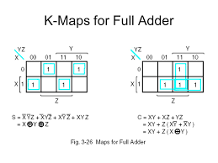
- Advanced implementation does not use the sum of products form for the full adder, but implements full adder with two half adders and an OR gate.
  - The first HA takes inputs 1 and 2
  - The second HA takes inputs of the output to HA1’s Sum and another input 3 (that skips the first half adder).
  - Carry for the FA makes use of the OR gate to check if either HA produced a carry out.
- (Binary Adders) Full adders are combined in a cascade or iterative way to form a binary adder that is standard component, e.g. involved in arithmetic...saves time in design.
- (Binary Adder/Subtractor) The 1’s complement is achieved with XOR gates tied to the number that is subtracted and the Modular input (1=Subtract) which carries in 1 therefore becomes the 2’s complement for subtraction. With Modular input of 0 it is a regular adder.
- (Overflow) An overflow condition is detected by observing the carry into the sign bit position and the carry out of the sign bit poisition. If these two carries are not equal (XOR) an overflow has occurred. Overflow is comparable to the situation of shifting the sign bit out of position (over 1).
- Adders can work in stages where the output carry can be wired to input carry of a next stage.
Decoders

Multiplexers
- The multiplexer (aka data selector) acts like an electronic switch that selects one of 2^n sources, using n selection lines and directs inputs to a single destination.
- Each of the 2^n inputs is applied as an input to an AND gate. Selection lines are decoded to select a particular AND gate. The outputs of the AND gates are applied to a single OR gate that provides the one-line output.
- Selector lines can be denoted as s₂s₁s₀ for example instead of introducing new signal names.
- Input lines will always be labeled I₀,I₁,...up to I₂^{n}

Review of Chapters 5 and 6

Function tables
- Charts all the inputs and outputs of a flip flop, including rising and falling clock edges.
Clk D Q Q’
↑ 0 0 1
↑ 1 1 0
- Table 6.3
Mode Control
s1 s0 Register operation
0 0 No change
0 1 Shift right
1 0 Shift left
1 1 Parallel load
- Table 6.6
Clear_b CLK Load Count Function
0 X X X Clear to 0
1 ↑ 1 X Load inputs
1 ↑ 0 1 Count next binary state
1 ↑ 0 0 No change

- Flip flop Diagrams
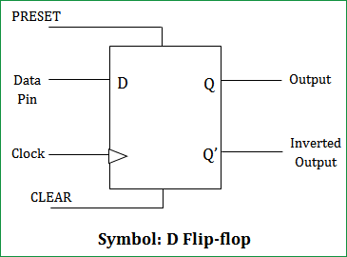
  - D flip-flop
Direct set sets Q = 1 asynchronously
Direct reset sets Q = 0 interupts the clock!
D = 1 with Direct reset off sets Q = D

  - JK flip-flop
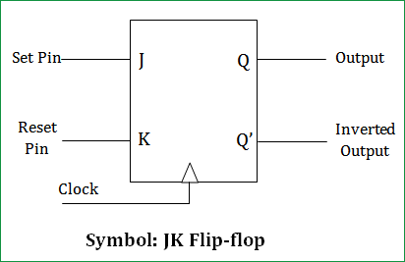
J = 1 sets Q = 1
(if K = 0)
K = 1 resets Q = 0
(if J = 0)
J=1,K=1 changes Q and Q’ (compl.)
J=0,K=0 leaves it unchanged

  - T flip-flop
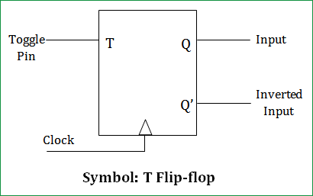
T = 1 complements thereby “flipping” Q and Q’

T = 0 leaves it unchanged

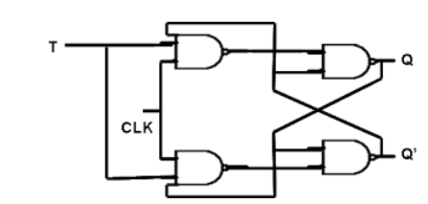

  - Inner look at T flip-flop
More notes about flip-flops (generally)
- There are three operations that flip-flops can do: Set, Reset or Complement.
- The complement operation is only supported by T and JK flip flops, but not D flip flops.
- JK flip flop is the only type that supports all 3 operations. D does Set/Reset. T is complement only. All flip-flops do however support an asynchronous reset (not the same as synchronous)
- Flip flops are known to be devices that are edge sensitive (synchronized to a clock pulse) as opposed to level-sensitive latches, which are the internal parts of the flip-flop.
- Flip flops are either rising edge or falling edge triggered.

D flip flop
- The D flip-flop characteristic equation: Q(t+1)=D
- Positive-edge trigerred D flip-flop with active-low asynchronous reset
  - The reset is wired to all three latches in the flip-flop.
- FF Construction of D-type: Construction #1 with 2 latches and an inverter. Construction #2 is with 3 S’R’ latches in a multi-level wiring that connects the clock and signal data input two first two, which then drive a third latch.
- In both constructions the last latch contains the flip flop outputs. (works nice)
- Functionality of D flip-flop:
- Before the clock activates the flip flop the value on the input must be stabilized (hold time)
- Then at the clock pulse either rising/falling edge the input (D) is transferred onto the output Q.
- This is known as the Set operation. There is an asynchronous reset provided in the D flip flop.
- However there is no complement operation (at least without use of external circuitry).
- NOTES
  - Master/Slave (Construction #1) – An inverter on the clock signal controls which changes….and the output of 2nd latch is has the value from the previous stage of the master latch.
  - Positive/Negative D flip-flops: The D-type flip flop may be either positive-edge or negative-edge triggered. The simplest construction produces a negative edge d-type flip flop. To produce the positive edge trigeered D-type flip flop simply requires another inverter.
  - Why is it named a D flip flop: It is named after the d-type latch (transparent latch) used to build it, in which S and R inputs of a SR latch are tied together by a single D input line.
    - Recall that a latch is level-sensitive also there is the very real problem with latches that if they aren’t “carefully managed” there are certain states that are indeterminate and that is bad if not taken into account.
  - The S’R’ latch used in Construction #2 has the properties: S=0 will set and R=0 will reset.

JK flip flop
- The JK flip-flop characteristic equation: Q(t+1) = JQ’+K’Q
- Construction of JK flip flop is with a D flip-flop and a multiplexer that translates the characteristic equation into the physical circuitry needed as input to D-type flip-flop.
- (page 273 has a complete diagram).
- Construction:
- These have 3 inputs and 2 outputs, of which 1 is clock, and 2 are “data” inputs, denoted J and K.
- Functionality of JK flip flops:
- When J = 1 the flip-flop is “Set” to 1, and when K = 1 the flip-flop is “Reset” to 0. The reset in is synchronous, unlike D type flip-flop’s asynchronous reset. Also J=1 with K=1 complements the signal...which also unlike D type is able to complement the primary output line (changing the signals on Q and Q’ around, which cannot be done with D type). Also something that D cannot really do without severing ties to the clock is to leave the state unchanged, unless external circuitry is used, but a JK flip flop can achieve this by simply setting J = 0 and K = 0 !

T flip-flop specifics
- The T flip-flop characteristic equation: Q(t+1) = TQ’ + T’Q NOTE: XOR logic
- Construction:
  - By using JK flip-flop and tying the two J and K inputs together with a single input wire
  - Or with a D flip-flop that is XOR looped back with a T input signal
- Functionality:
  - T flip-flops only performs the operation of complementing, or leaving state unchanged.
  - T = 1 complements
  - T = 0 leave state unchanged.
  - T flip flops being a special case of the JK flip flop can support 1 true operation complementing, and 1 other “function” which is to leave the state unchanged.
Registers and Counters review
- Registers and counters are types of functioning sequential circuits (broad definition)
- (definition) Register: A stored n-bits clocked together, may involve some combinational logic.
- (definition) Counter: a register connected with logic to perform a sequence of states.
- Register functionality
- Like the flip-flops that make up each register the register itself has an asynchronous reset to clear all flip-flops to logic 0.
- The use of the reset obstructs normal clocked operation and therefore must be set to off for normal operation of it.
- (definition) Control signals: A way of create the effect of a gated clock without actually wiring any logic to the clock.
- This is good because otherwise gating the clock would and does lead to problems like propagation delay.
- By using control signals to operate registers they can be used at designated times instead of at every pulse of the clock, making them more flexible in practical use.
- Parallel loading is the action of simultaneously loading or activating all flip flops in the register,
- Parallel load is accomplished by feeding registers with external data input. The preferred way to do this is not to cut ties with the master clock, which could create more problems like propagation and out of sync with clock circuit, but placing on the data bus, leaving the clock directly connected.
- That way EDGE TRIGGERED FLIP FLOP INPUTS including clock still drives the register but a Load signal determines whether or not it functions for some specific operation or none even.
- Bottom line is always avoid logic on the clock, even when going for the gated clock effect instead use the load input for that along the data path.
  - If Load input = 0, this drives No Change...depends on what implementation of flip-flop!!
  - If Load input = 1, this drives input of the data bus lines and a parallel load.
  - The clock edge synchronization ensures that all flip-flops in a register are simulatenously loaded.

Shift registers (concept only)
Has a direction of shift to the neighboring cells, in a chain of flip-flops accepting Serial input at the first, and producing Serial output from the last, in between positions the register shifts everything 1 bit in the direction of shift out on each clock cycle.
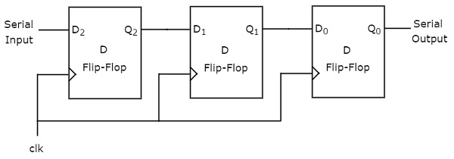

- Serial transfers are done 1 bit at a time from source register to destination register, as opposed to parallel (all at once)
- The two primary types of shifting is unidirectional or bidirectional
- In terms of transfers to prevent data loss a process of recircling the data back onto the source register is used.
- Shift registers are complicated to design, e.g. because to work they need to only be active for the correct number of cycles that moves all the bits from one register to another. e.g. a 4-bit register takes 4 cycles of shifting to transfer a 4-bit word from that register to the target register, at which point the shift activity needs to be paused in order to maintain the value stored.
- Serial shifters are lower cost, lower power, and take less space on chip though they have disadvantages which is their slower speed relative to parallel loading.

Counters - Ripple Counters (Asynchronous)
- A ripple counter is a register that goes through a prescribed sequence of states using an asynchronous approach, but careful it looks synchronized but it is not.
  - The use of a flip-flop which has a edge triggered design that is typically used with a clock but in the case of the ripple counter this clock signal is mostly used to trigger complementing flip flops previously in a rippling or cascading chain.
- The first position for the counter may be clock driven, but it may not be. (Not too sure need to see)
- Each later flip flop in the counting circuit has another flip flop output connected to the clock input (or where the clock input would go if it were clocked but it isn’t.)
- The mechanism of ripple counting is strange as well because on the way towards incrementing the count, the temporary state is not that typical way of counting, e.g. from binary 3, 0011 to binary 4 0100 requires in between steps towards state binary 2, 0010 then binary 0 0000 before it increments the 4’s place to get binary 4.
- Another interesting question might be to find out how long does the ripple counter take to process since it isn’t limited by a clock pulse generated so it may in fact be much faster than that.
- The types of counter include incrementing and decrementing, but there is also a up/down counter with enough wiring to count up or down.
- (see page 356 firgure 6.8 a and b for the design of a counter using T and D flip flops)

Synchronous counters (Synchronous)
- The synchronous binary counters work differently from the ripple counter but also somewhat similar in that complementing a lower order bit and a negative edge trigger for the next order bit.
- The clock pulses however do drive flip-flops and so it requires the use of JK or T flip flops since those can complement and are clock synchronized
- Recall since a T flip-flop can be constructed by a D flip-flop with an XOR gate in front therefore it is possible to construct this these as well. (In fact that is likely what is done). Or just use the JK.
- Designing a synchronous binary counter with AND gates and JK flip flops: (see pg361 figure 6.12)
  - Reminders about JK Flip flop Functionality:
    - J=0 K=0 leaves state unchanged and no counting occurs at this setting.
    - J=1 K=1 will complement and that helps the counting to occur
  - Enable input is wired to all the flip flops
  - It is directly wired to begin the count on the first flip flop only
  - In subsequent bit positions it is like a cascade or ripple with combinational logic that ties the enable input (counting on) with the complemented output of the previous flip-flops.
  - Put yet another way the nth flip flop is primed for counting when the n-1 flip flop becomes a 1, because the next cycle should make Qn-1 = 0 and therefore Qn = 1.
  - This is a good example of the gated clock effect as well, since it shows how each flip flop is turned off or on, and not used at every clock pulse without adding logic to the clock signal.
  - NOTE: In an up-down counter the inputs driving the next flip in order of lower to higher bit make use of both the complemented signal and uncomplemented signal output This is what allows the circuit to go in either direction counting up or down. If up = 1, it counts up, and if down = 1 it counts down (if both are 0 down, both 1 up)

Binary counter with parallel load (final topic)
  - Binary counters often require a parallel-load capability for transferring an initial binary number into the counter prior to the count operation.
  - Design of the parallel load binary synchronous counter
    - Inputs:
      - Count – whether or not to go through the defined sequence of counting
      - Load – whether to turn off the count operation and parallel load from data path in
      - CLK – the clock signal
      - Clear – active-low asynchronous, when equal to 0 clears the register
      - Also the data path in
    - Outputs:
      - Carry out – useful for tying together with other counters
      - Also the data path out

